* What causes of air pollution in Dhaka city?

Dhaka, the capital of Bangladesh, It was termed as the most polluted city in the world. There have been some estimations of emission from different sectors (e.g. transport, industry, residential etc.). The pollutants in consideration were NOx, SOx, CO, CO2, PM2.5, and PM10 etc.

* The causes….!

Several sources of air pollution in Bangladesh

* industrial emissions
* vehicular emissions
* Overpopulation
* 86% of the total motor vehicles in this city emit black smoke
* 1.3 million people in Dhaka depend on 6 x10 metric ton of wood and other non-conventional fuel in each year, which causes thick smoke from their cooking stoves.
* What are the harmful pollutants?
* carbon monoxide (CO)
* hydrocarbons (HC)
* nitrogen oxides(NOx)
* Carbon Di oxide(CO2)
* Sulfur dioxide (SO2),
* Ozone (O3),
* particulate matter(PM10-less than or equal to 10um, PM2.5

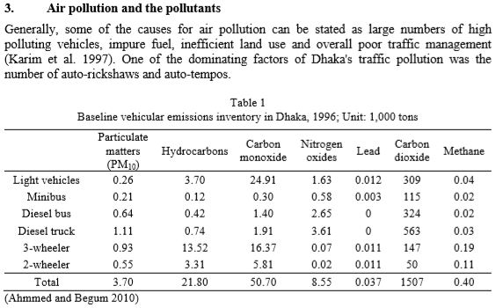

Their increase was most remarkable in Dhaka as the proportion of such two stroke engine vehicles in the total vehicle population rose from 2.2% in 1982-83, to 18% in 1990-91, and as high as 23% in 1996-97 (Karim et al. 1997). It was estimated that an auto-rickshaw emitted 30 times more pollutants than a normal car (Karim 1997). The annual fuel consumption by the vehicles in Dhaka metropolitan was 77% diesel, 18% petrol, and 5% octane before the introduction of Compressed Natural Gas (CNG) (Sarker and Alam 2001).

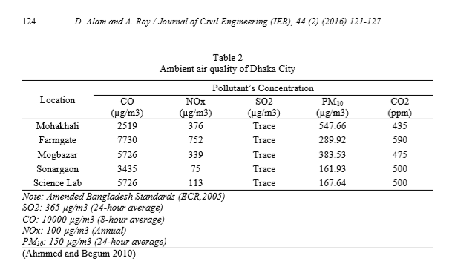

The most important pollutants with respect to transportation systems can be identified as Carbon monoxide (CO), Sulfur dioxide (SO2), Nitrogen oxides (NOx), Ozone (O3), Hydrocarbons (HC) and Suspended Particulate Matter (SPM) (Karim 2001). Particulate matter with an aerodynamic diameter of less than or equal to 10µm (PM10) was added to the list in 1987 (Ahmmed and Begum 2010). Observing from (Nasiruddin 2001), the trend for concentration of SO2, O3, CO and NOx, their values go up in dry season significantly. The same has been also true for PM2.5 and PM10

**Suspended Particulate Matter (SPM), Particulate Matter (PM), PM10, PM2.5 and Black Carbon (BC)**

It was observed that from January to April (dry and calm season) the ambient concentration of Suspended Particulate Matter (SPM) exceeded the WHO standard for daily average hourly concentration of 150-230gm/m3. Average SPM levels were about double than the Bangladeshi standard of 200 µg/m3 in residential areas and are more than 10 times higher than the WHO guidelines of 120 µg/m3 (24 hours) in commercial areas (Sarker and Alam 2001). The maximum daily average hourly concentration of SPM observed was 570 gm/m3 at Motijheel in January (Islam and Islam, 1990). Interestingly, this study did not show any alarming situation for ambient SO2 and NO2 concentrations.

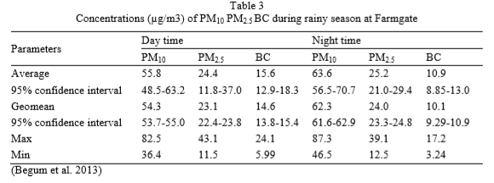

Oxides of nitrogen include nitric oxide (NO) and nitrogen dioxide (NO2). The calculation of NOx indicated that bus and minibus (diesel operated) and motor car have the significant contribution of NOx (30%), followed by heavy-duty vehicles (truck and tanker) (28%). On the other hand, three wheelers are the least contributing modes of NOx in Dhaka City. Considering CO emission by each transportation mode for the year 1996, it was estimated that auto-rickshaws and cars are the major contributors (35%), followed by Motorcycles (24%). It has also been noted that auto-rickshaw is the major contributor of HC emission (56%), followed again by motorcycle (26%). Mass transit had little contribution of HC emission. Annual average increases of 6.5% in NOx, 5.8% in HC, 5.9% in CO, 5.6% in PM and 6% in SOx emissions were observed from 1981 to 1996.

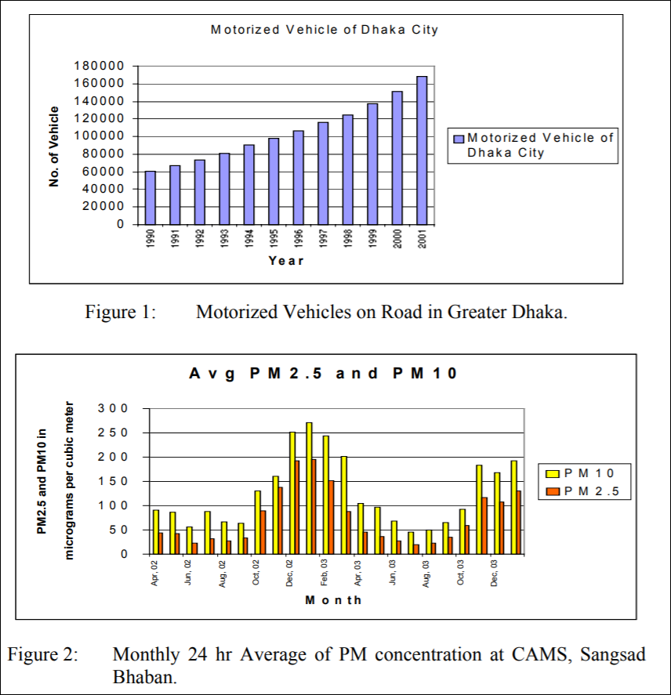

**Concluding Words**

This file summarizes and depicts the research results on air pollution of Dhaka. It also explains impacts of some of the projects and policy decisions. The past experiences and information will be helpful for emission control strategies and decision-making processes as there is still only a couple of active air quality monitoring station. It may also act as a baseline study for estimating present and future air quality and emission from different sources. In that case we can use some sensors to detect these pollutants, so that we can get clear concept about pollutants and take necessary actions.